CARRY LOOK AHEAD ADDER
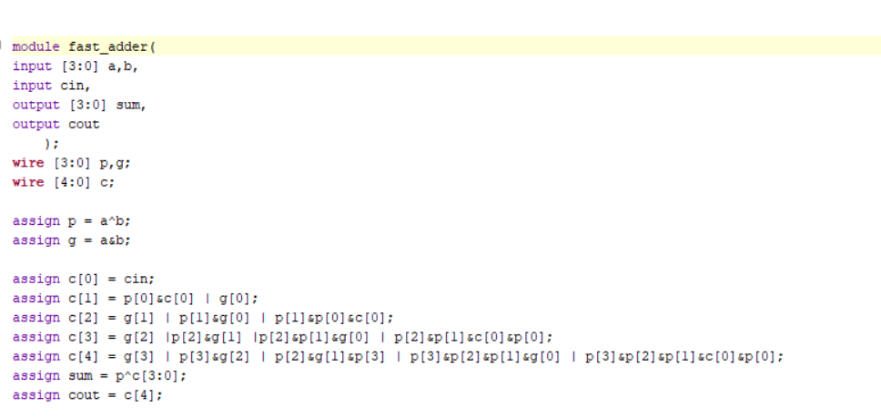
TESTBENCH
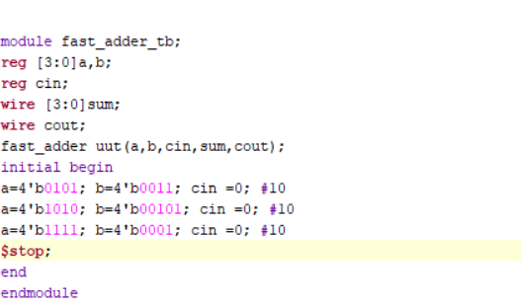
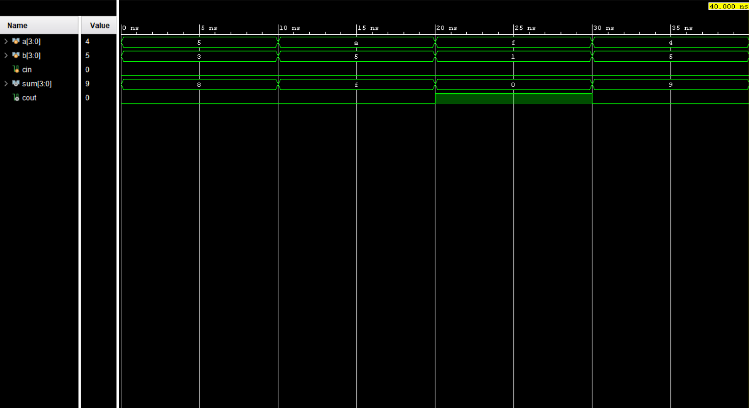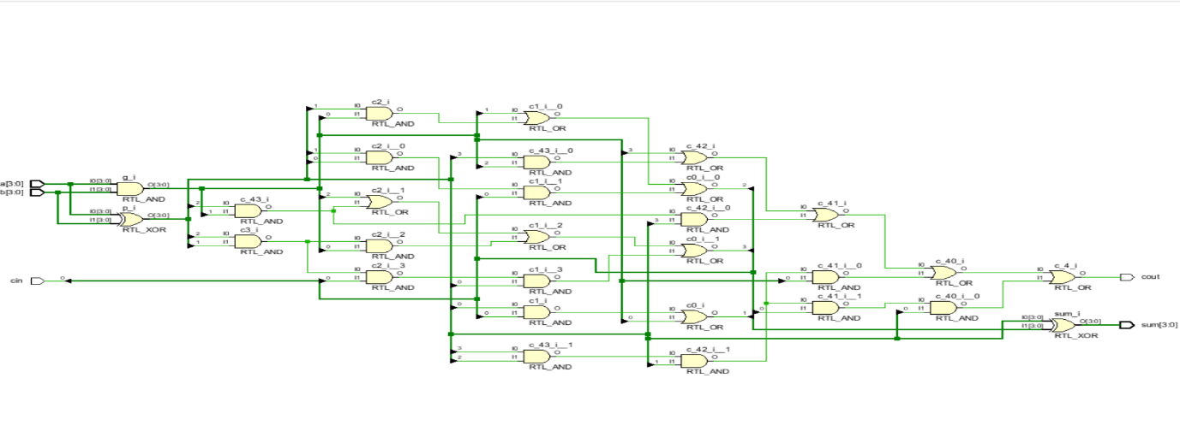
RRAM FAULT MODELLING
`timescale 1ns / 1ps

module rram_cell #(
parameter integer V_FORM_MV = 2500,
parameter integer V_SET_MV = 1500,
parameter integer V_RESET_MV = 2000,
parameter integer R_HRS_OHM = 1000000,
parameter integer R_LRS_OHM = 1000,
parameter integer R_PRI_OHM = 10000000
)(
input wire clk,
input wire rst_n,
input wire v_apply_en,
input wire [15:0] v_in_mv,
output reg [1:0] cell_state,
output reg [31:0] r_out_ohm,
output reg forming_done,
output reg set_done,
output reg reset_done
);

localparam [1:0] PRISTINE = 2'b00;
localparam [1:0] HRS = 2'b01;
localparam [1:0] LRS = 2'b10;

localparam [15:0] FORM_MV = V_FORM_MV[15:0];
localparam [15:0] SET_MV = V_SET_MV[15:0];
localparam [15:0] RESET_MV = V_RESET_MV[15:0];

reg transition_done;

always @(posedge clk or negedge rst_n) begin
if (!rst_n) begin
cell_state <= PRISTINE;
r_out_ohm <= R_PRI_OHM;
forming_done <= 1'b0;
set_done <= 1'b0;
reset_done <= 1'b0;
transition_done <= 1'b0;
end else begin

forming_done <= 1'b0;
set_done <= 1'b0;
reset_done <= 1'b0;

if (!v_apply_en)
transition_done <= 1'b0;

if (v_apply_en && !transition_done) begin
case (cell_state)

PRISTINE: begin
if (v_in_mv >= FORM_MV) begin
cell_state <= LRS;
r_out_ohm <= R_LRS_OHM;
forming_done <= 1'b1;
transition_done <= 1'b1;
end
end

HRS: begin
if (v_in_mv >= SET_MV) begin
cell_state <= LRS;
r_out_ohm <= R_LRS_OHM;
set_done <= 1'b1;
transition_done <= 1'b1;
end
end

LRS: begin
if (v_in_mv >= RESET_MV) begin
cell_state <= HRS;
r_out_ohm <= R_HRS_OHM;
reset_done <= 1'b1;
transition_done <= 1'b1;
end
end

default: begin
cell_state <= PRISTINE;
r_out_ohm <= R_PRI_OHM;
end

endcase
end
end
end

endmodule

TEST BENCH
`timescale 1ns / 1ps

module rram_tb;

reg clk;
reg rst_n;
reg v_apply_en;
reg [15:0] v_in_mv;

wire [1:0] cell_state;
wire [31:0] r_out_ohm;
wire forming_done;
wire set_done;
wire reset_done;

rram_cell #(
.V_FORM_MV (2500),
.V_SET_MV (1500),
.V_RESET_MV (2000),
.R_HRS_OHM (1000000),
.R_LRS_OHM (1000),
.R_PRI_OHM (10000000)
) DUT (
.clk (clk),
.rst_n (rst_n),
.v_apply_en (v_apply_en),
.v_in_mv (v_in_mv),
.cell_state (cell_state),
.r_out_ohm (r_out_ohm),
.forming_done(forming_done),
.set_done (set_done),
.reset_done (reset_done)
);

initial clk = 1'b0;
always #5 clk = ~clk;

task print_state;
begin
case (cell_state)
2'b00: $display(" State=PRISTINE | R=%0d Ohm", r_out_ohm);
2'b01: $display(" State=HRS | R=%0d Ohm", r_out_ohm);
2'b10: $display(" State=LRS | R=%0d Ohm", r_out_ohm);
default: $display(" State=UNKNOWN | R=%0d Ohm", r_out_ohm);
endcase
end
endtask

task apply_pulse;
input [15:0] voltage_mv;
input integer cycles;
begin
v_in_mv = voltage_mv;
v_apply_en = 1'b1;
repeat(cycles) @(posedge clk);
#1;
v_apply_en = 1'b0;
v_in_mv = 16'd0;
repeat(2) @(posedge clk);
#1;
end
endtask

initial begin
rst_n = 1'b0;
v_apply_en = 1'b0;
v_in_mv = 16'd0;

repeat(4) @(posedge clk);
#2;
rst_n = 1'b1;
repeat(2) @(posedge clk);

$display("==============================================");
$display(" RRAM Unipolar Switching Sim (Fixed + Lock) ");
$display("==============================================");
print_state;
$display("");

$display("[STEP 1] FORMING -> 2600 mV applied");
apply_pulse(16'd2600, 4);
print_state;
#30;

$display("[STEP 2] READ after FORMING");
apply_pulse(16'd200, 2);
print_state;
#30;

$display("[STEP 3] RESET -> 2100 mV applied");
apply_pulse(16'd2100, 4);
print_state;
#30;

$display("[STEP 4] READ after RESET");
apply_pulse(16'd200, 2);
print_state;
#30;

$display("[STEP 5] SET -> 1600 mV applied");
apply_pulse(16'd1600, 4);
print_state;
#30;

$display("[STEP 6] READ after SET");
apply_pulse(16'd200, 2);
print_state;
#30;

$display("[STEP 7] SUB-THRESHOLD -> 1200 mV (no change expected)");
apply_pulse(16'd1200, 4);
print_state;
#30;

$display("[STEP 8] RESET again -> 2100 mV");
apply_pulse(16'd2100, 4);
print_state;
#30;

$display("[STEP 9] SET again -> 1600 mV");
apply_pulse(16'd1600, 4);
print_state;

$display("");
$display("==============================================");
$display(" Simulation Complete");
$display("==============================================");
$finish;
end

always @(posedge clk) begin
if (forming_done) $display(" *** FORMING DONE t=%0t ***", $time);
if (set_done) $display(" *** SET DONE t=%0t ***", $time);
if (reset_done) $display(" *** RESET DONE t=%0t ***", $time);
end

endmodule
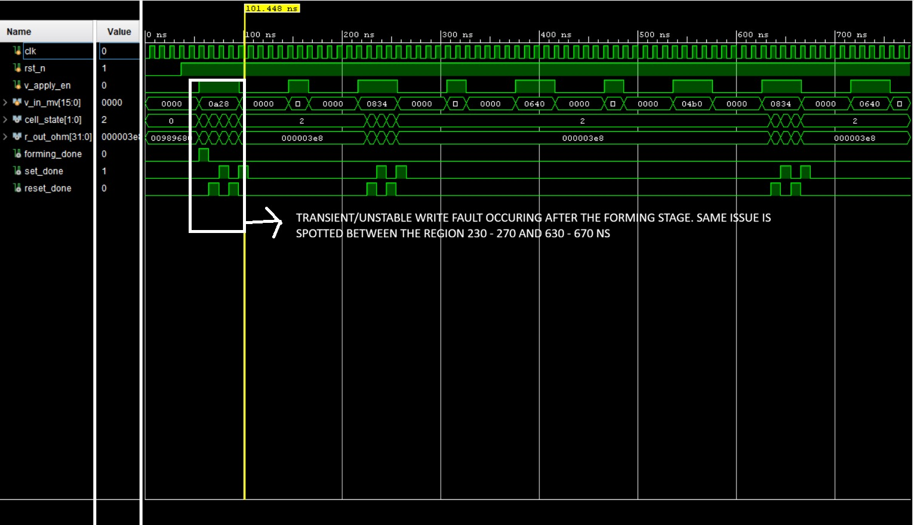
SPI PROTOCOL
module SPI_protocol(
input wire clk,
input wire rst,
input wire start,
input wire cshold,
input wire miso,
input wire wdelay_enable,
input wire [7:0]data_tx,
output reg mosi,
output reg sclk,
output reg cs,

output reg [7:0]data_rx,
output reg done
);

parameter c2t_d = 4;
parameter t2c_d = 4;
parameter w_delay = 6;

reg [7:0] tx_shift, rx_shift;
reg [2:0] bit_cnt;
reg [7:0] delay_cnt;
reg [2:0] state;

localparam IDLE = 3&#39;d0,
CS_SETUP = 3&#39;d1,
TRANSFER = 3&#39;d2,
CS_HOLD = 3&#39;d3,
WAIT_SPI = 3&#39;d4;

reg clk_div;

always @(posedge clk) begin
if(rst)

clk_div &lt;= 1&#39;b0;
else
clk_div &lt;= ~clk_div;
end

always @(posedge clk_div) begin
if(rst) begin
cs &lt;= 1&#39;b1;
mosi &lt;= 1&#39;b0;
done &lt;= 1&#39;b0;
sclk &lt;= 1&#39;b0;
data_rx &lt;= 8&#39;d0;
tx_shift &lt;= 8&#39;d0;
rx_shift &lt;= 8&#39;d0;
bit_cnt &lt;= 3&#39;d0;
delay_cnt &lt;= 8&#39;d0;
state &lt;= IDLE;
end
else begin
case(state)

IDLE: begin
done &lt;= 1&#39;b0;

sclk &lt;= 1&#39;b0;

if(start) begin
cs &lt;= 1&#39;b0;
tx_shift &lt;= data_tx;
rx_shift &lt;= 8&#39;d0;
bit_cnt &lt;= 3&#39;d7;
delay_cnt &lt;= c2t_d;
mosi &lt;= data_tx[7];

state &lt;= CS_SETUP;
end
end

CS_SETUP: begin
if(delay_cnt == 0) begin
state &lt;= TRANSFER;
end
else begin
delay_cnt &lt;= delay_cnt - 1&#39;b1;
end

end

TRANSFER: begin
sclk &lt;= ~sclk;

if(sclk == 1&#39;b0) begin
rx_shift[bit_cnt] &lt;= miso;
end

else begin
if(bit_cnt == 0) begin
sclk &lt;= 1&#39;b0;
delay_cnt &lt;= t2c_d;

if(wdelay_enable)
state &lt;= WAIT_SPI;
else
state &lt;= CS_HOLD;
end

else begin
bit_cnt &lt;= bit_cnt - 1&#39;b1;
mosi &lt;= tx_shift[bit_cnt - 1&#39;b1];
end
end
end

WAIT_SPI: begin
sclk &lt;= 1&#39;b0;

if(delay_cnt == 0) begin
delay_cnt &lt;= w_delay;
state &lt;= CS_HOLD;
end
else begin
delay_cnt &lt;= delay_cnt - 1&#39;b1;
end
end

CS_HOLD: begin
sclk &lt;= 1&#39;b0;

if(delay_cnt == 0) begin

if(cshold == 1&#39;b0)
cs &lt;= 1&#39;b1;
else
cs &lt;= 1&#39;b0;

data_rx &lt;= rx_shift;
done &lt;= 1&#39;b1;
state &lt;= IDLE;
end
else begin
delay_cnt &lt;= delay_cnt - 1&#39;b1;
end
end

default: begin
state &lt;= IDLE;
end

endcase
end
end
endmodule

TESTBENCH

module SPI_protocol_tb;

reg clk;
reg rst;g cshold;
reg miso;
reg wdelay_enable;
reg [7:0] data_tx;

wire mosi;
wire sclk;
wire cs;
wire [7:0] data_rx;
wire done;

SPI_protocol uut (
.clk(clk),
.rst(rst),
.start(start),
.cshold(cshold),
.miso(miso),
.wdelay_enable(wdelay_enable),
.data_tx(data_tx),
.mosi(mosi),
.sclk(sclk),
.cs(cs),
.data_rx(data_rx),
.done(done)
);
initial clk = 0;
always #5 clk = ~clk;

reg [7:0] slave_shift_reg = 8'hA5;

always @(posedge sclk) begin
if (!cs) begin
miso <= slave_shift_reg[7];
slave_shift_reg <= {slave_shift_reg[6:0], mosi};
end
end

initial begin
rst = 1;
start = 0;
cshold = 0;
miso = 0;
wdelay_enable = 0;
data_tx = 8'h00;

#20;
rst = 0;
#20;

data_tx = 8'h3C;
start = 1;
#20;
start = 0;

wait(done == 1);
$display("Transaction 1 Complete!");
$display("Sent: 0x3C, Received: 0x%h", data_rx);

#100;

slave_shift_reg = 8'h5A;
data_tx = 8'hFF;
start = 1;
#20;
start = 0;

wait(done == 1);
$display("Transaction 2 Complete!");
$display("Sent: 0xFF, Received: 0x%h", data_rx);

#200;
$finish;
end

endmodule
